Developing Damper Catalogs

Damper Air Performance Test Report and Catalog Example

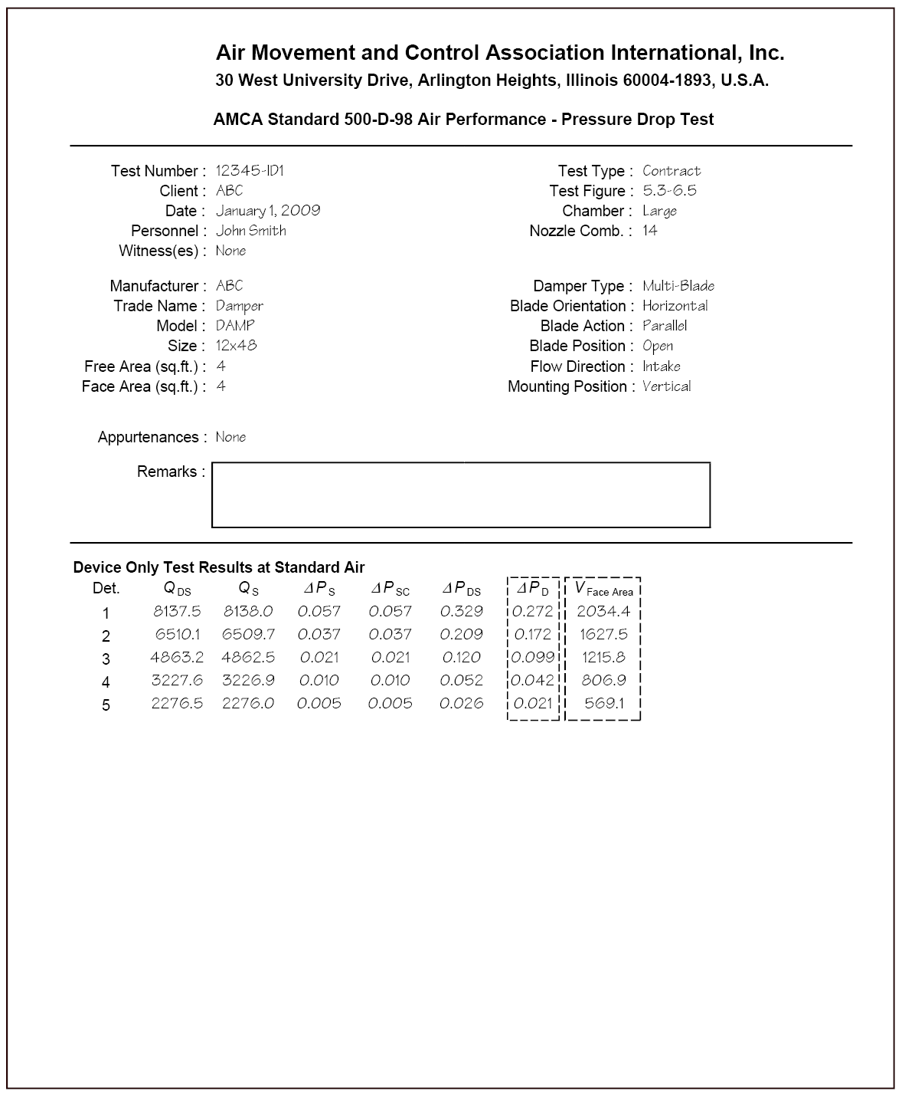

Figure 1

Example Damper Air Performance Test Report

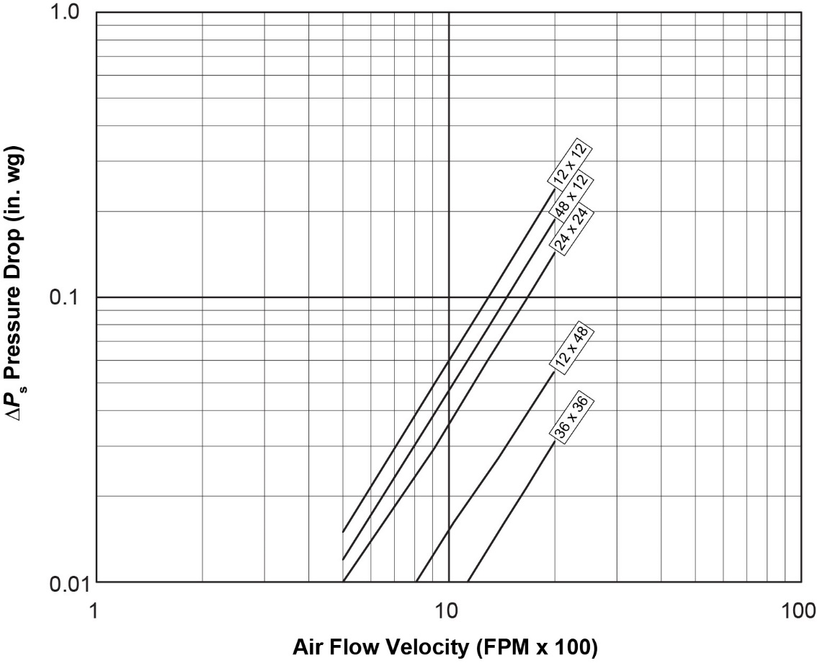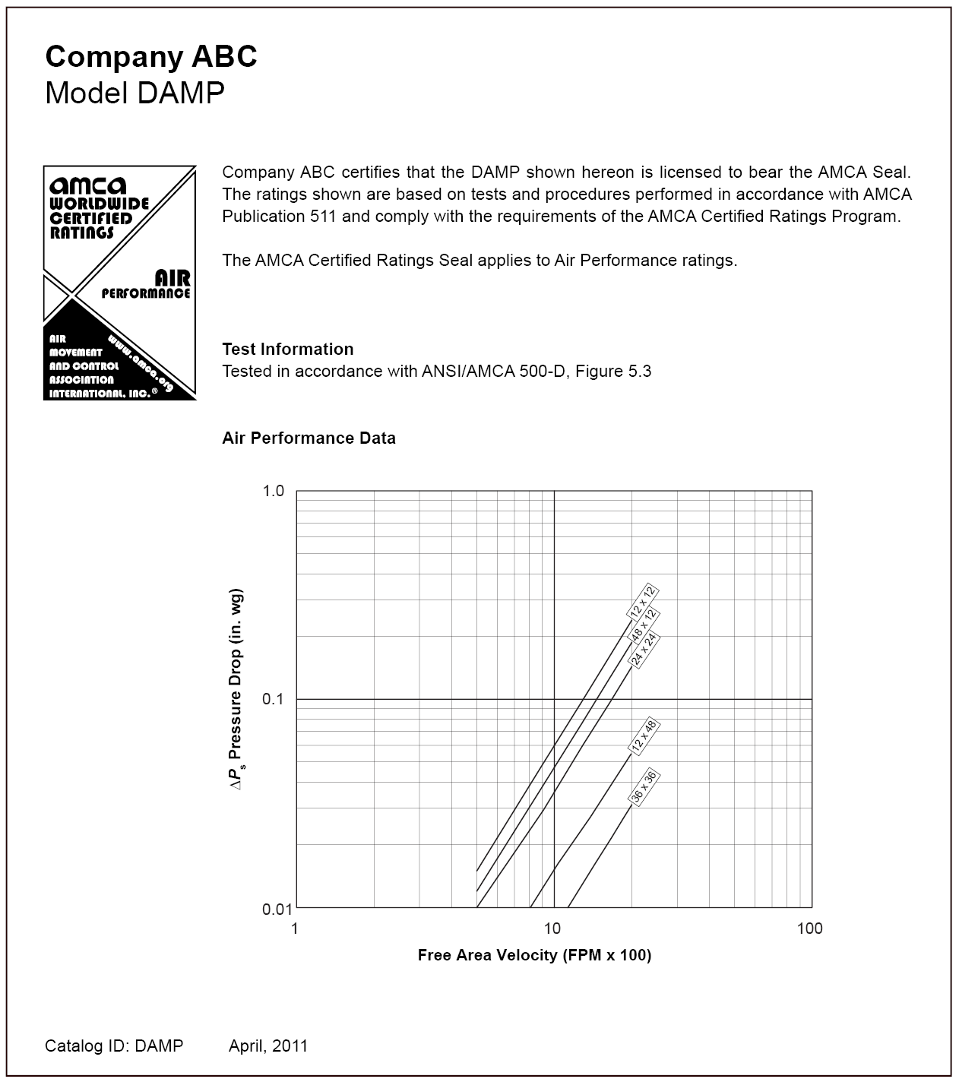

Note:

This sample catalog contains only the items required for certification. Additional information, such as construction details, installation information, pictures, etc., may be added as necessary.

Figure 2

Example Damper Air Performance Catalog

Volume Control Damper Leakage Performance Test Report and Catalog Example

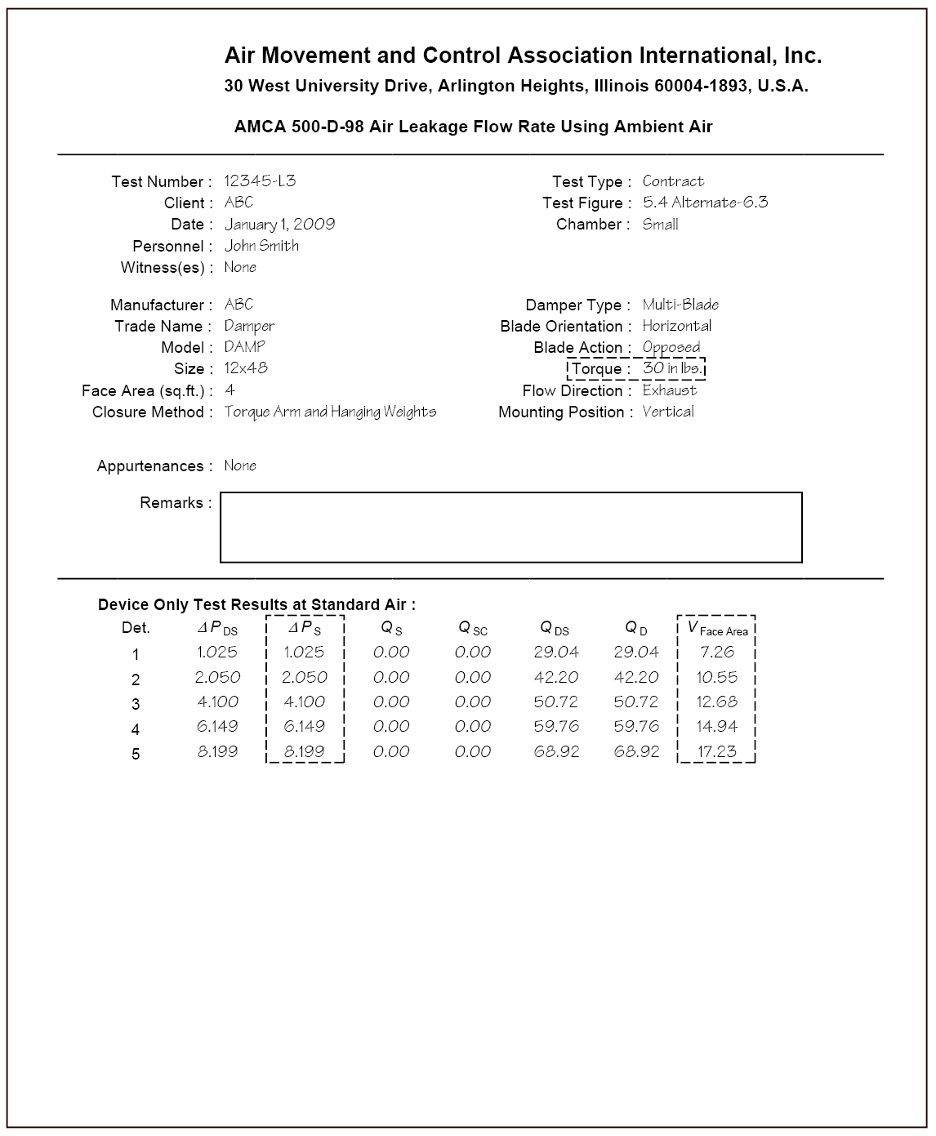

**Figure 3**

**Example Volume Control Damper Air Leakage Test Report**

Example 1

The company certifying the leakage performance only conducted tests on the two required sizes. The maximum single section width of this model is 60 in. Because only the two required sizes were tested, the catalog data does not have to distinguish the leakage performance at different widths.

|  |  |  |  |  |
| --- | --- | --- | --- | --- |
|  | Leakage Class Test Results | | | |
| Width x Height | 1 in. wg | 4 in. wg | 6 in. wg | 8 in. wg |
| 12 x 48 in. | 1 | 1 | 1 | 1 |
| 60 x 36 in. | 1A | 1 | 2 | 2 |

Example Catalog Table

|  |  |  |  |
| --- | --- | --- | --- |
| Leakage Class | | | |
| 1 in. wg | 4 in. wg | 6 in. wg | 8 in. wg |
| 1 | 1 | 2 | 2 |

Example 2

The same company certifies the same damper as in Example 1. This time they test one optional size, 16 in. x 36 in., along with the two required sizes. This allows them to catalog leakage class 1A performance at 1 in. wg on dampers 16 in. and wider.

|  |  |  |  |  |
| --- | --- | --- | --- | --- |
|  | **Leakage Class Test Results** | | | |
| **Width x Height** | **1 in. wg** | **4 in. wg** | **6 in. wg** | **8 in. wg** |
| **12 x 48 in.** | 1 | 1 | 1 | 1 |
| **16 x 36 in.** | 1A | 1 | 1 | 1 |
| **60 x 36 in.** | 1A | 1 | 2 | 2 |

Example Catalog Table

|  |  |
| --- | --- |
|  | **Leakage Class** |
| **Damper Width** | **1 in. wg** | **4 in. wg** | **6 in. wg** | **8 in. wg** |
| **Less than 16 in.** | 1 | 1 | 1 | 1 |
| **16 to 60 in.** | 1A | 1 | 2 | 2 |

Example 3

The same company again certifies the same damper as in Example 1. This time they test two optional sizes, 16 in. x 36 in. and a 48 in. x 36 in., along with the two required sizes. This not only allows them to catalog leakage class 1A performance at 1 in. wg on dampers 16 in. and wider, but also allows them to catalog class 1 performance at up to 8 in. wg on dampers all the way up to 48 in. wide.

|  |  |  |  |  |
| --- | --- | --- | --- | --- |
|  | **Leakage Class Test Results** | | | |
| **Width x Height** | **1 in. wg** | **4 in. wg** | **6 in. wg** | **8 in. wg** |
| **12 x 48 in.** | 1 | 1 | 1 | 1 |
| **16 x 36 in.** | 1A | 1 | 1 | 1 |
| **48 x 36 in.** | 1A | 1 | 1 | 1 |
| **60 x 36 in.** | 1A | 1 | 2 | 2 |

Example Catalog Table

|  |  |
| --- | --- |
|  | **Leakage Class** |
| **Damper Width** | **1 in. wg** | **4 in. wg** | **6 in. wg** | **8 in. wg** |
| **Less than 16 in.** | 1 | 1 | 1 | 1 |
| **16 to 60 in.** | 1A | 1 | 1 | 1 |
| **48.01 to 60 in.** | 1A | 1 | 2 | 2 |

Figure 4

Example Volume Control Damper Air Leakage Test Results and Corresponding Published Data

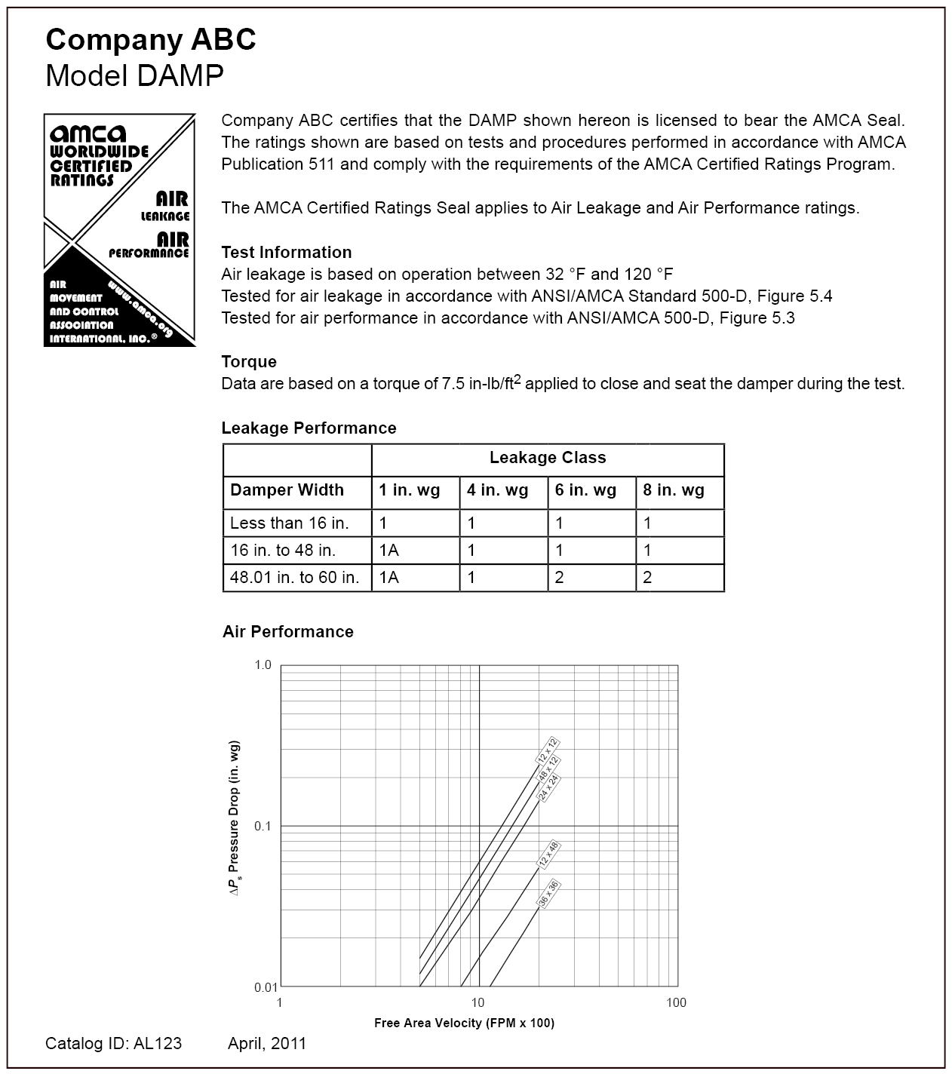

Air Flow Velocity (FPM x 100)

Note:

This sample catalog contains only the items required for certification. Additional information, such as construction details, installation information, pictures, etc., may be added as necessary.

Figure 5

Example Volume Control Damper Air Leakage Catalog

**Ultra-Low-Leakage Damper Leakage Test Report and Catalog Example**

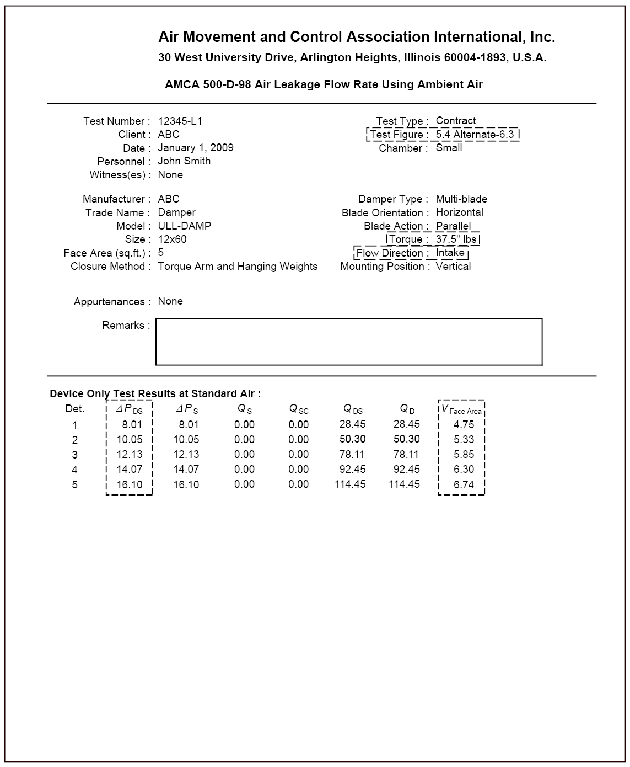

Figure 6

Example Ultra-Low-Leakage Damper Air Leakage Test Report

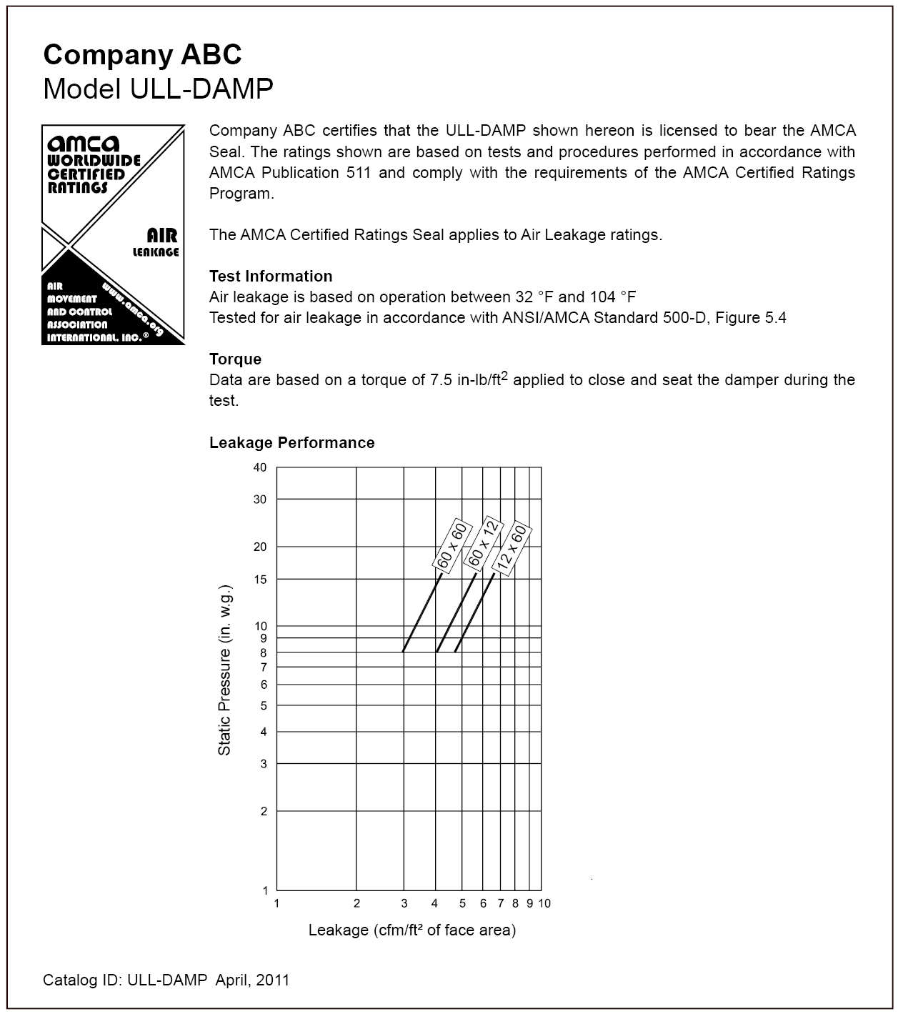

Note:

This sample catalog contains only the items required for certification. Additional information, such as construction details, installation information, pictures, etc., may be added as necessary.

Figure 7

Example Ultra-Low-Leakage Damper Air Leakage Catalog

Bubble-Tight Damper Leakage Performance Test Report and Catalog Example

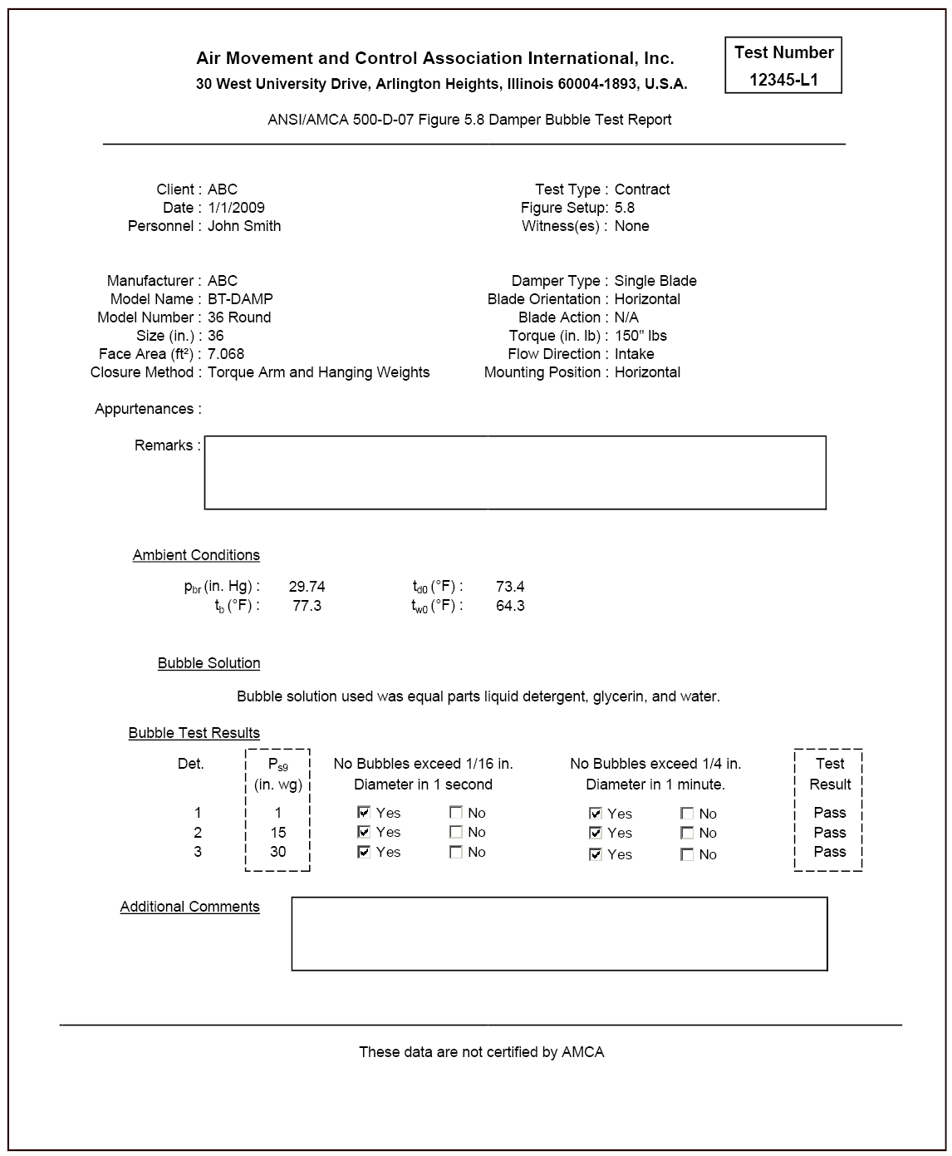

Figure 8

Example Bubble-Tight Damper Air Leakage Test Report

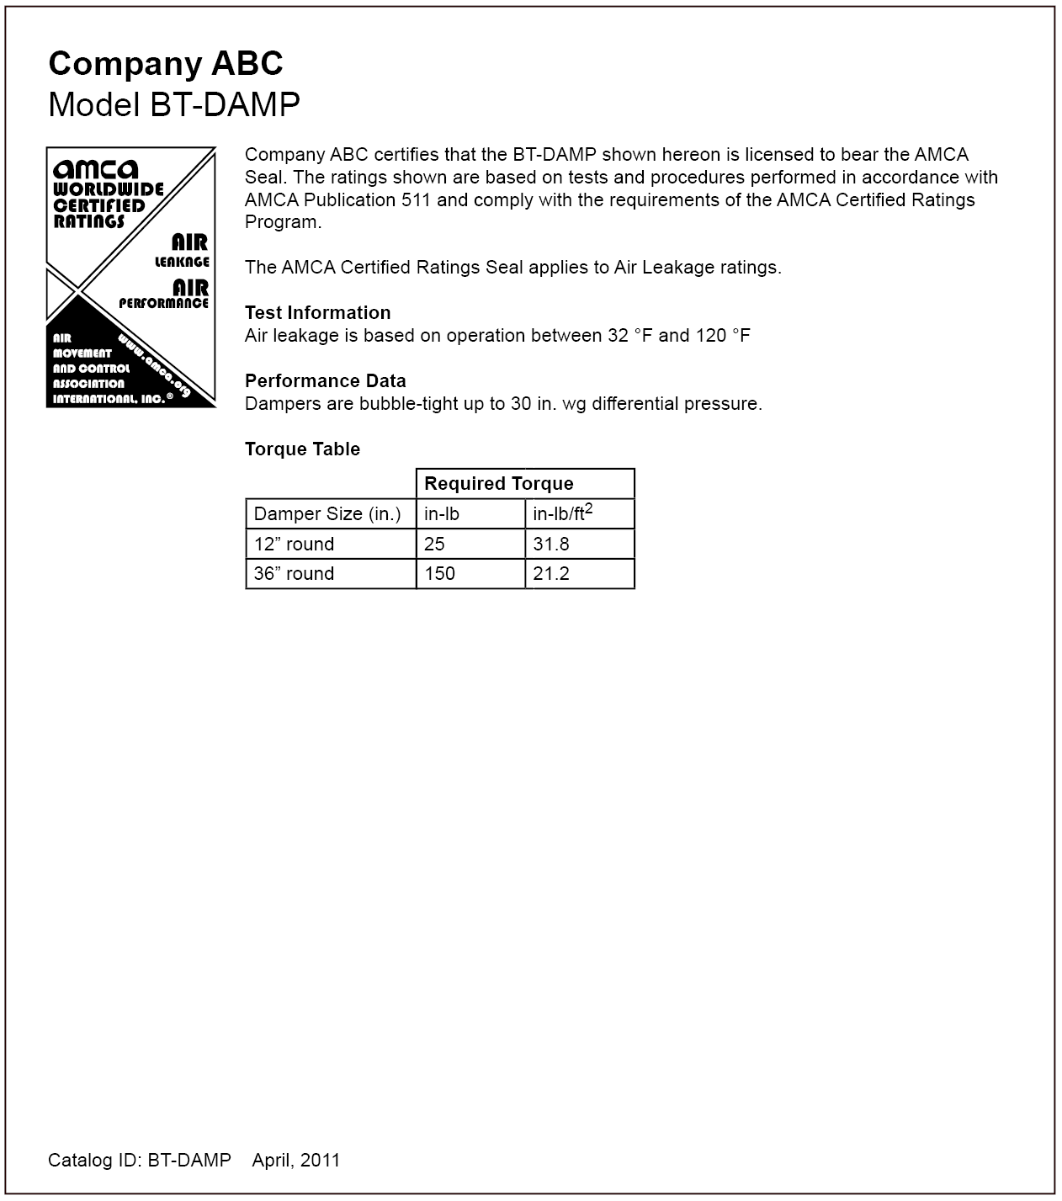

Note:

This sample catalog contains only the items required for certification. Additional information, such as construction details, installation information, pictures, etc., may be added as necessary.

Figure 9

Example Bubble-Tight Damper Air Leakage Catalog

Backdraft Damper Leakage Performance Test Report and Catalog Example

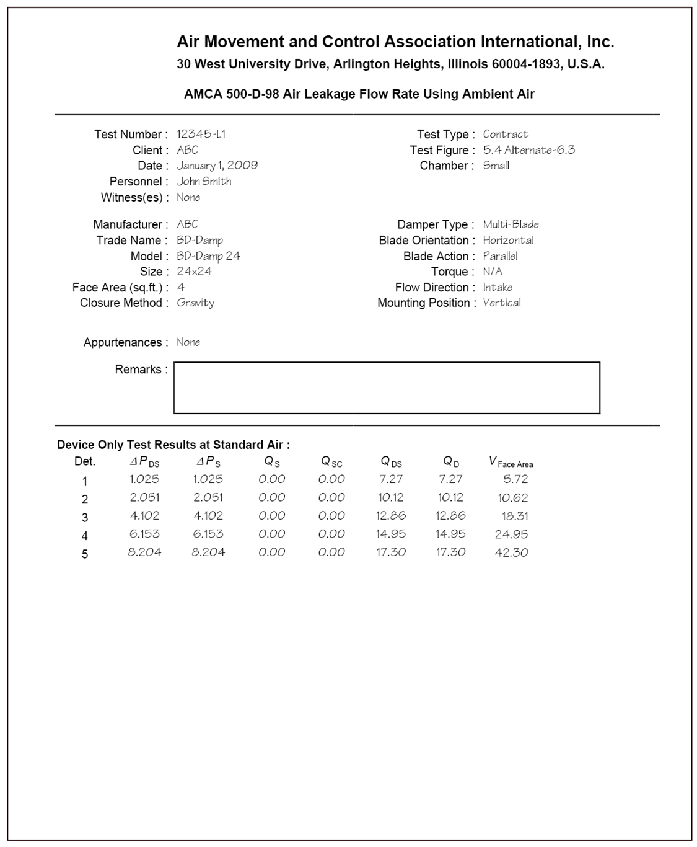

Figure 10

Example Backdraft Damper Air Leakage Test Report

**Example Test Data**

**Example 1**

The company certifying the backdraft damper leakage performance only conducted tests on the three sizes required by section 19. In this example the minimum single section width is 6 in., the minimum single section height is 8 in., the maximum single section width is 48 in. and the maximum single section height is 60 in. Because only the three required sizes were tested the catalog data only lists a single leakage rate for the entire model size range at each cataloged pressure. Note that the cataloged performance reflects the poorest performance of the three samples at each cataloged pressure.



**Example 2**

In addition to testing the three required sizes the company certifying the backdraft damper leakage performance conducted tests on the two optional sizes described in section 19. For the purpose of this example we will assume the same minimum and maximum single section sizes as in example 1. Because the optional sizes were tested the Licensee can distinguish between the cataloged performance of dampers with both a width and height 24 inches or greater and dampers with either a width or height less than 24 inches. The cataloged leakage rate for dampers with a width and height 24 inches or greater shall reflect the poorest performance of samples C, D, and E. The cataloged leakage rate for dampers with a width or height less than 24 inches shall reflect the poorest performance of samples A and B.





**Company ABC: Model BD-DAMP**

**Company ABC certifies that the BD-DAMP shown hereon is licensed to bear the AMCA Seal.**

**The ratings shown are based on tests and procedures performed in accordance with AMCA**

**Publication 511 and comply with the requirements of the AMCA Certified Ratings Program.**

**The AMCA Certified Ratings Seal applies to Air Leakage and Air Performance ratings.**

**Test Information**

* **Air leakage is based on operation between 32 °F and 120 °F**
* **Tests for air leakage were conducted in accordance with ANSI/AMCA Standard 500-D, Figure 5.4, in the intake direction~~, on a 24 in. x 24 in. sample~~**
* **Air performance testing conducted in accordance with ANSI/AMCA Standard 500-D, Figure 5.4**



**Air Leakage**

**Model BD-DAMP dampers with a width and height 24” or greater leak a maximum of:**

* **18 cfm/ft^2 or less at 1.0 inches w.g.**
* **43 cfm/ft^2 or less at 4.0 inches w.g.**

**Model BD-DAMP dampers with a width or height less than 24” leak a maximum of:**

* **38 cfm/ft^2 or less at 1.0 inches w.g.**
* **80 cfm/ft^2 or less at 4.0 inches w.g.**

**Air Performance**

**24”x24” Damper**

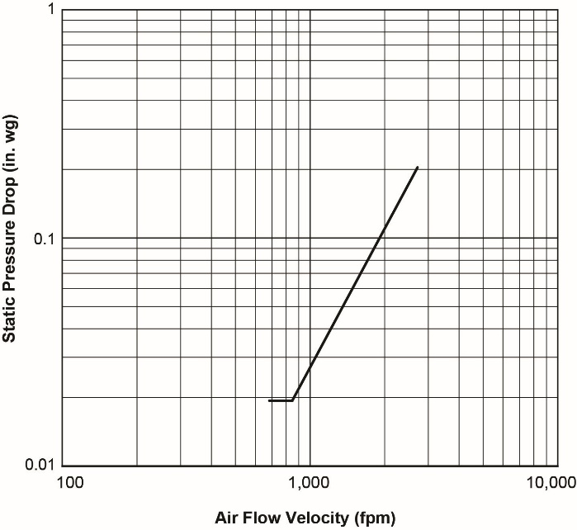

Note:

This sample catalog contains only the items required for certification. Additional information, such as construction details, installation information, pictures, etc., may be added as necessary.

Figure 11

Example Backdraft Damper Air Leakage Catalog

**Gravity Ventilator Air Performance Test Report and Catalog Example**

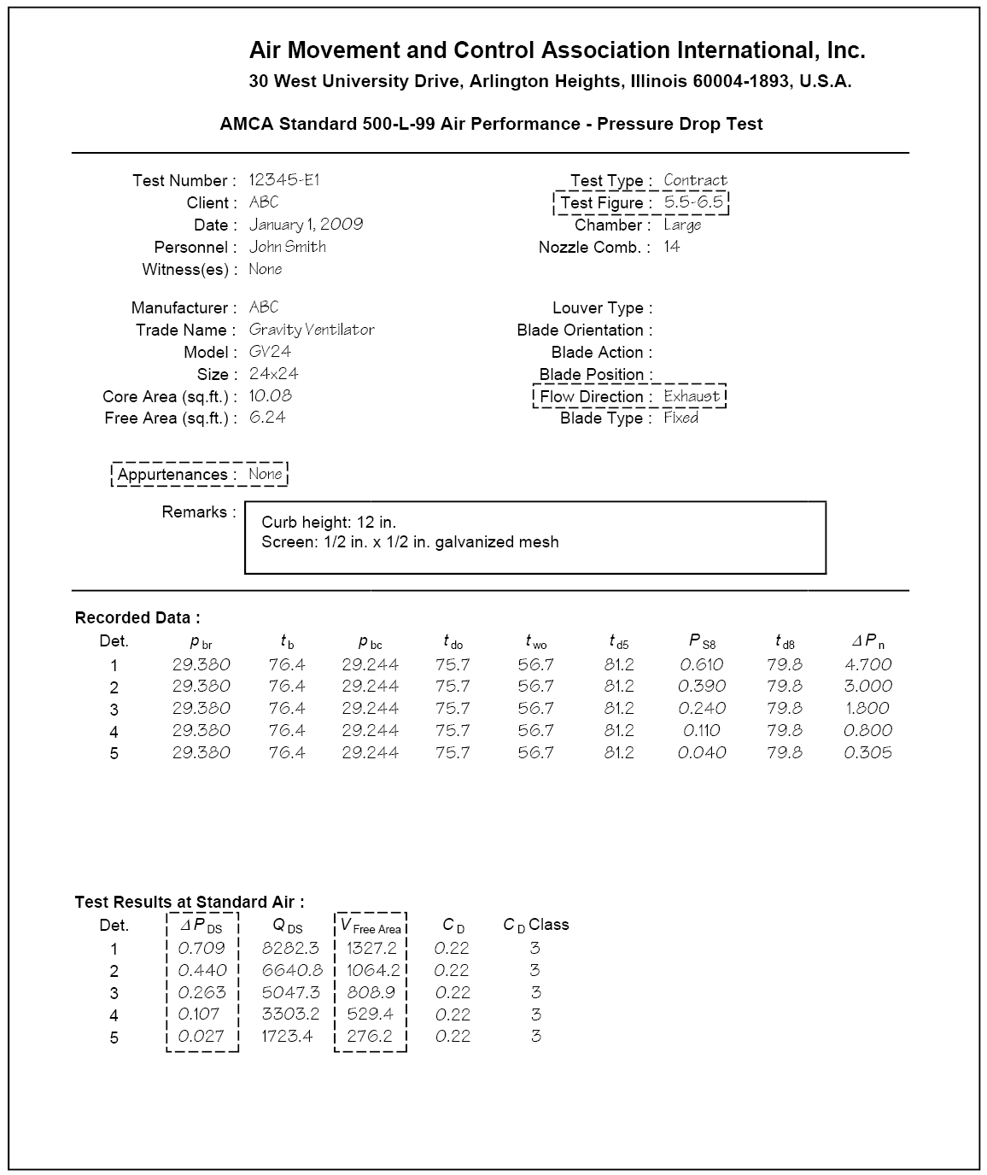

Figure 12

Example Gravity Ventilator Air Performance Test Report

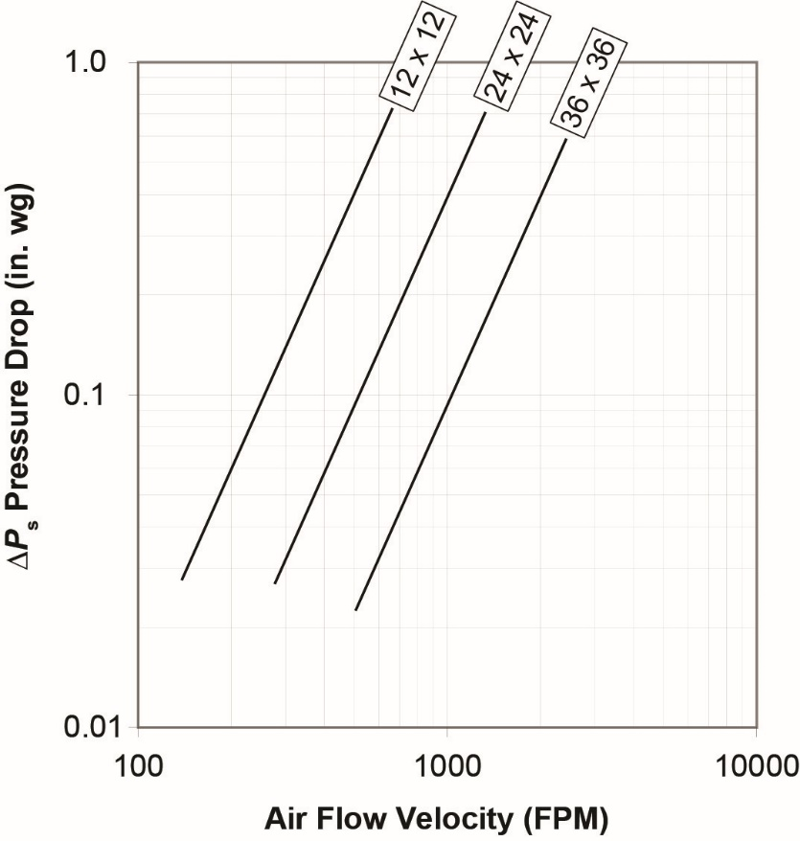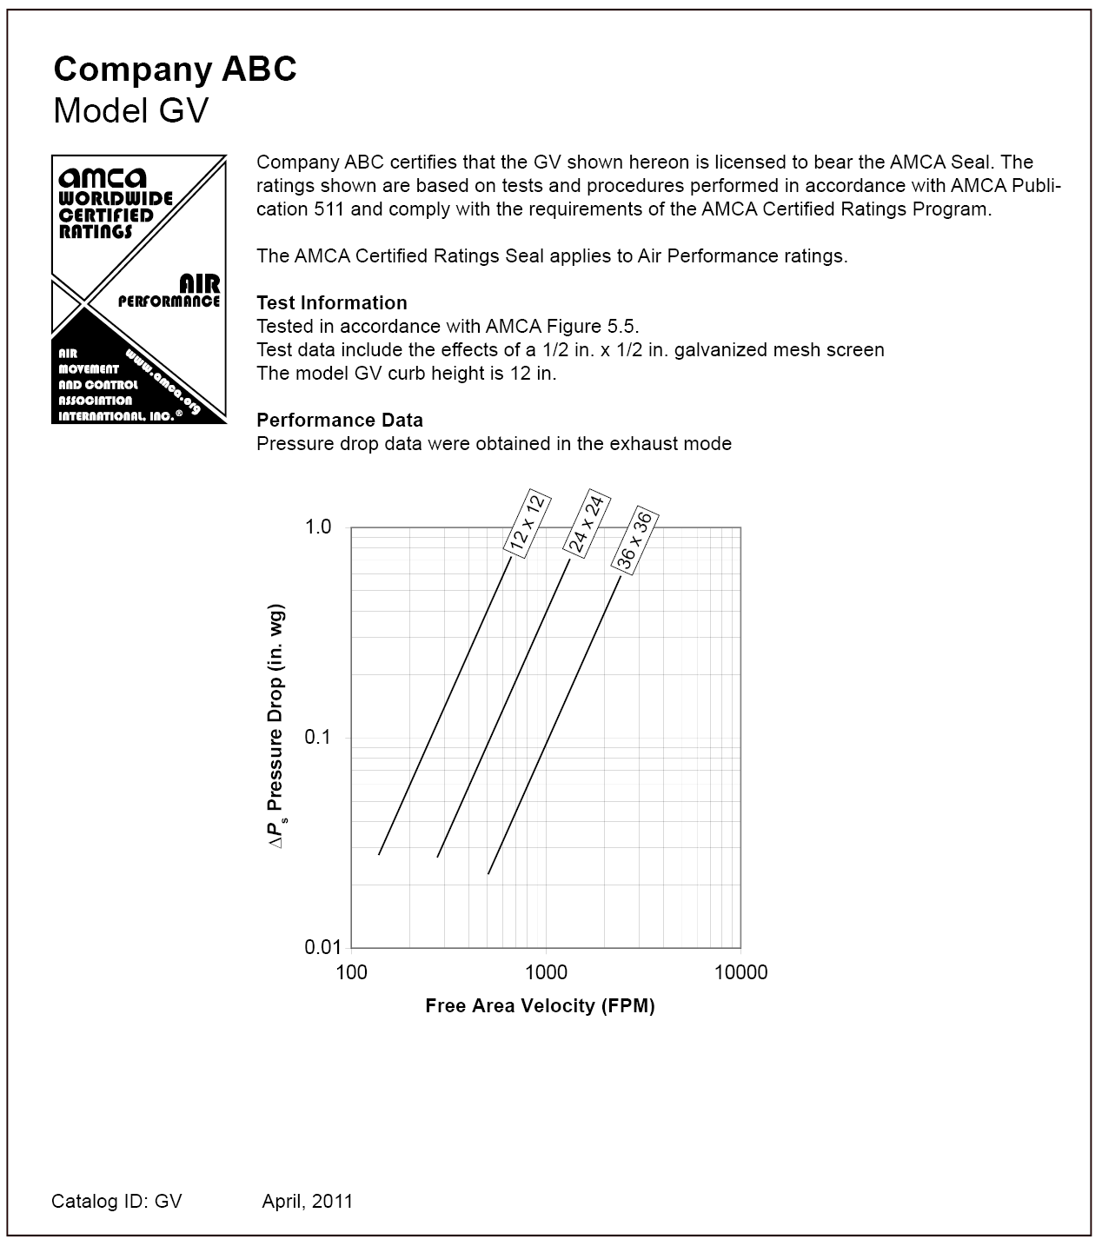Note:

This sample catalog contains only the items required for certification. Additional information, such as construction details, installation information, pictures, etc., may be added as necessary.

Figure 13

Example Gravity Ventilator Air Performance Catalog

Spiral Duct Leakage Performance Test Report and Catalog Example

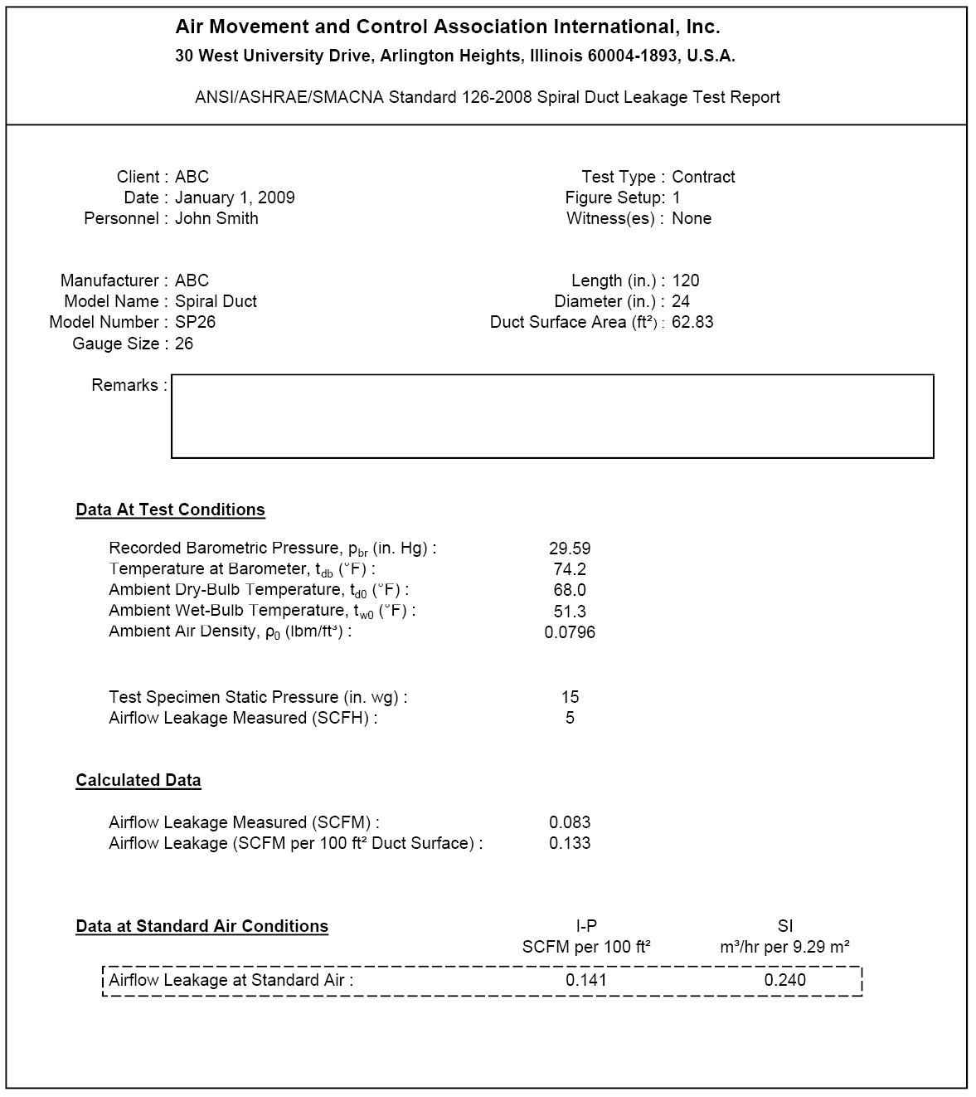

Figure 14

Example Spiral Duct Air Leakage Performance Test Report

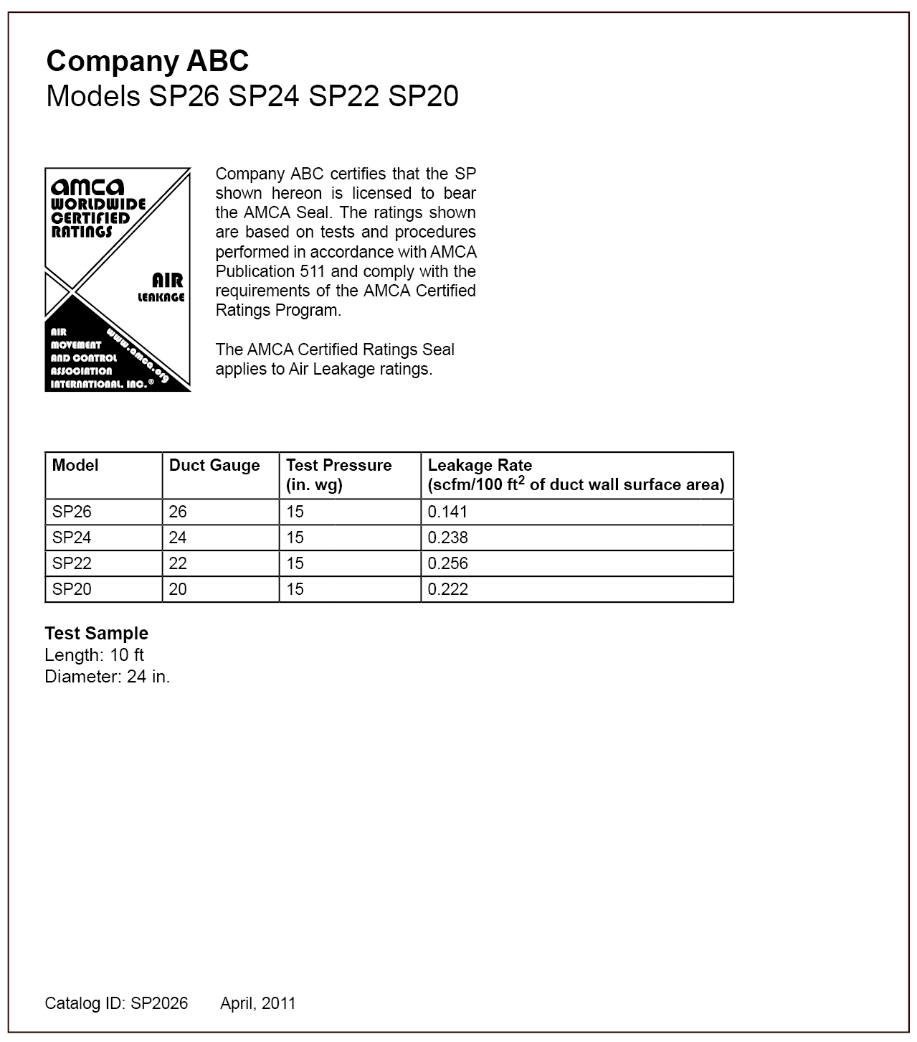

Note:

This sample catalog contains only the items required for certification. Additional information, such as construction details, installation information, pictures, etc., may be added as necessary.

Figure 15

Example Spiral Duct Air Leakage Catalog

Flat Oval Spiral Duct Leakage Performance Test Report and Catalog Example

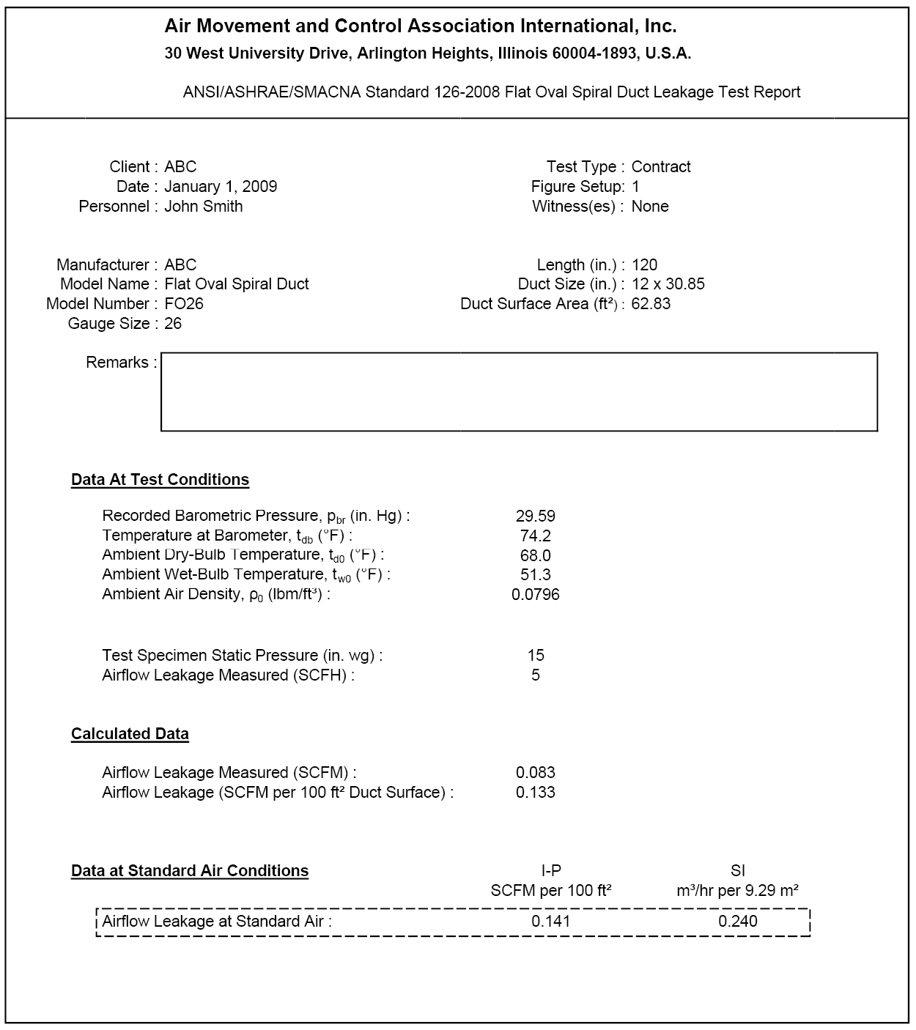

Figure 16

Example Flat Oval Spiral Duct Air Leakage Performance Test Report

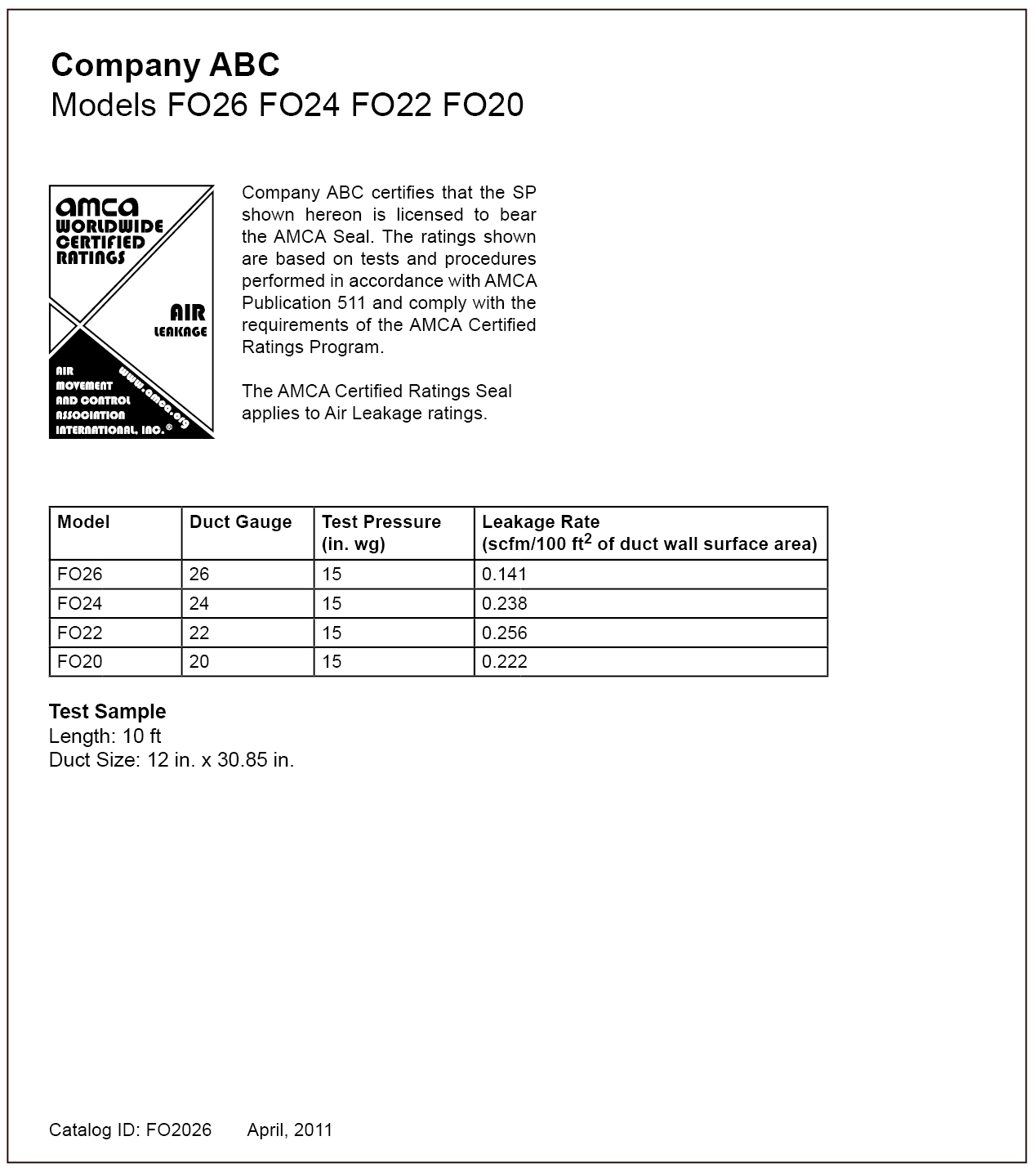

Note:

This sample catalog contains only the items required for certification. Additional information, such as construction details, installation information, pictures, etc., may be added as necessary.

Figure 17

Example Flat Oval Spiral Duct Air Leakage Catalog