CUSTOM QUICK-RESPONSE (QR) CODE ORDER FORM

- Large 1.75 inches (4.5 cm) wide x 2.75” (7 cm) high
- Small 1 inch (2.7 cm) wide x 1.8 inches (4.6 cm) high

Example:
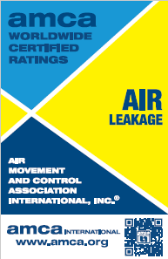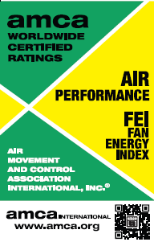

Manufacturing Member/Affiliate Company | Company, if different
Company: [Enter Company Name]  Address: [Enter Co Address]  City: [Enter Co City]  State/Province: [Enter State/Province]  Zip/Postal Code: [Enter Zip/Postal Code]  Country: [Enter Country] | Company: [Enter Company Name]  Address: [Enter Co Address]  City: [Enter Co City]  State/Province: [Enter State/Province]  Zip/Postal Code: [Enter Zip/Postal Code]  Country: [Enter Country]
Order Contact | File Type | Label Size
Full Name: Enter text.  Title: Enter text.  Email: Enter text.  Phone: Enter text. | ☐ JPEG  ☐ Vector | ☐ Large  ☐ Small
Engineering Contact | Marketing Contact
Full Name: Enter text.  Title: Enter text.  Email: Enter text.  Phone: Enter text. | Full Name: Enter text.  Title: Enter text.  Email: Enter text.  Phone: Enter text.

We agree that AMCA Certified Rating Program seals and labels are the property of the Air Movement and Control Association (AMCA) International, Inc. Reproductions are strictly prohibited and can only be obtained through AMCA International USA headquarters. Seals and labels can only be ordered and applied to products by the licensees who have the listed product in the appendices to the License Agreement and in accordance with AMCA Publication 11-22 and AMCA Publication 512-09. The company must have no outstanding invoices for other AMCA resources before delivery.

